Demonstrate field ownership
Now we'll test an important business rule:
HR owns employee information; Transport Operations owns transport information.
First, let's authenticate as the transport administrator.
In Swagger, execute POST /api/v1/auth/token with:
{
"tenant_id": "tenant-alpha",
"client_id": "transport-admin",
"client_secret": " transport-admin-secret-alpha-2026"}
Update transport-owned employee details
In Swagger, find:

PUT /api/v1/transport/employees/{employee_id}
1. Click Try it out.
2. Enter employee ID: EMP1001.
3. Use this request body:
{
"preferred_pickup_point_id": "PICKUP_BLR_001",
"shift_timing": "09:00-18:00",
"special_assistance_required": false,
"special_assistance_notes": null
}

4. Click Execute.
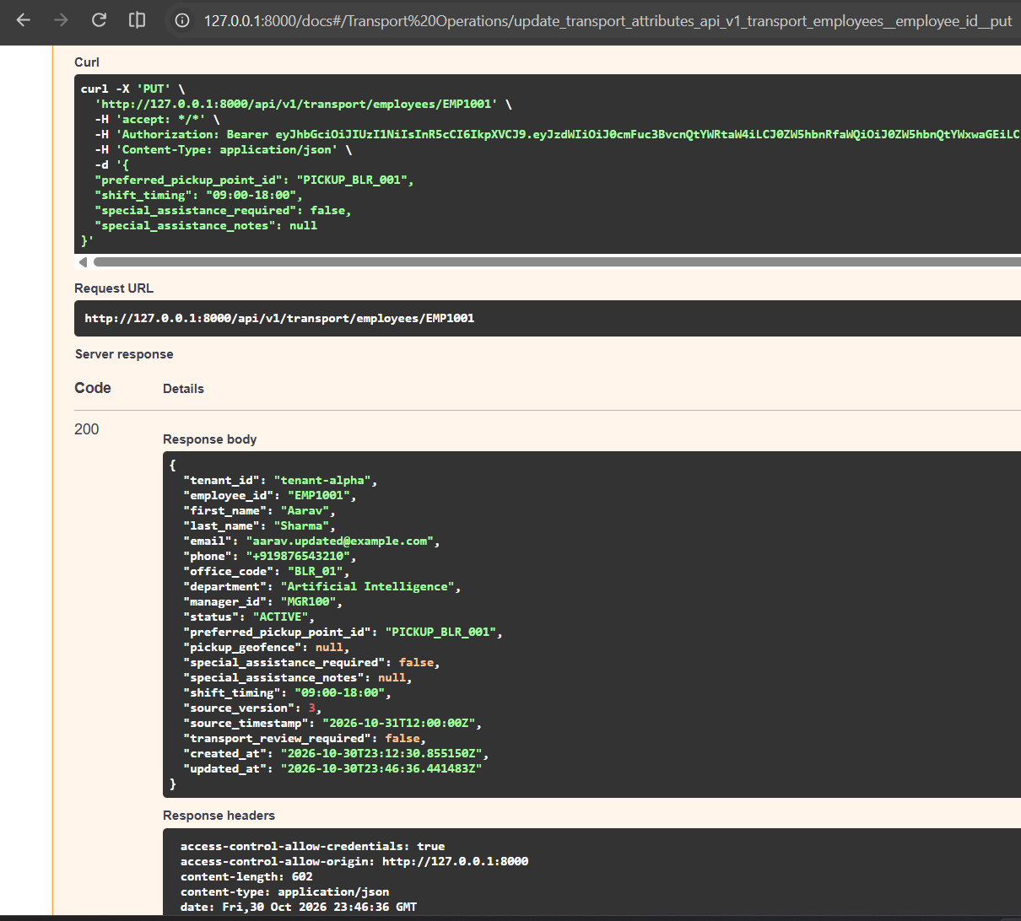

The response confirms that the transport administrator updated the transport-owned fields.
Test field ownership :

Now we need to prove that an HR update cannot overwrite transport-owned fields.
1. In Swagger, switch authorization back to your HR service token.
{
"tenant_id": "tenant-alpha",
"client_id": "hr-service",
"client_secret": "hr-client-secret-alpha-2026"
}
2. Execute POST /api/v1/roster/events.
3. Use a new idempotency key:
demo-batch-004

4. Submit this event:
{
"events": [
{
"event_id": "evt-demo-004",
"event_type": "UPDATE",
"employee_id": "EMP1001",
"source_version": 4,
"source_timestamp": "2026-10-31T13:00:00Z",
"first_name": "Aarav",
"last_name": "Sharma",
"email": "aarav.v4@example.com",
"office_code": "BLR_01",
"department": "Engineering",
"manager_id": "MGR100",
"status": "ACTIVE"
}
]
}
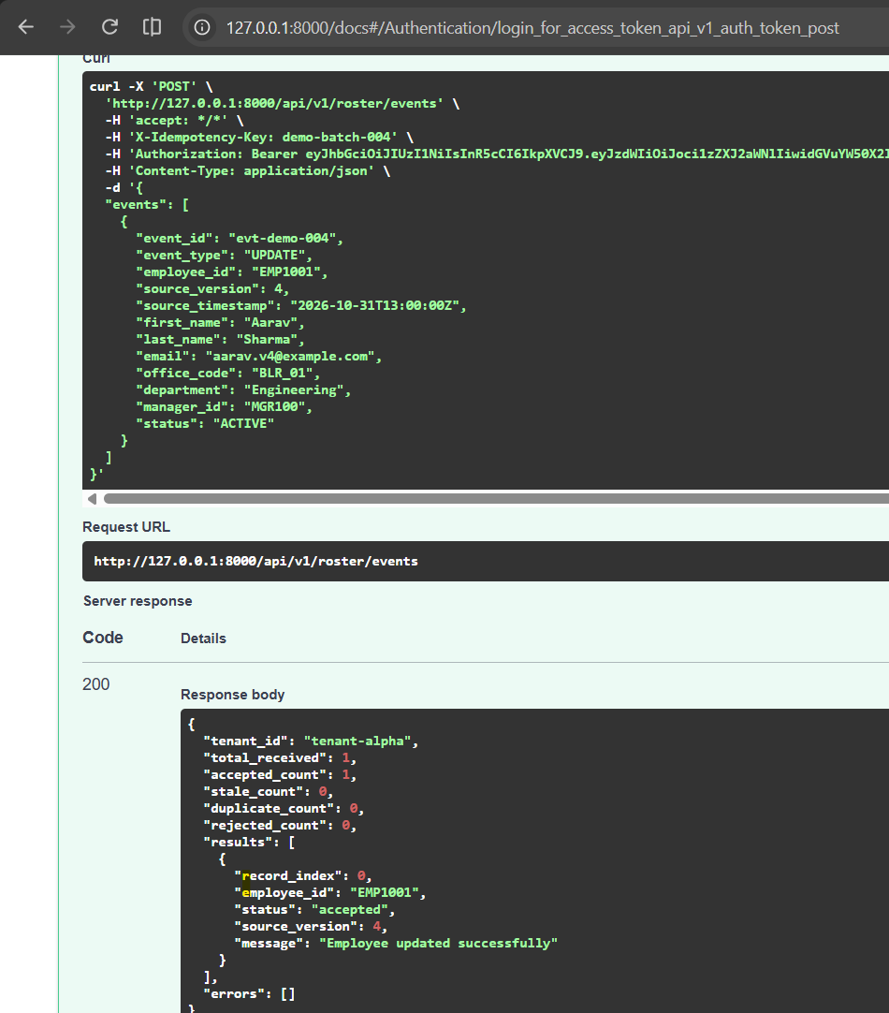
The HR update was accepted. Now we need to verify that it did not overwrite transport-owned fields.

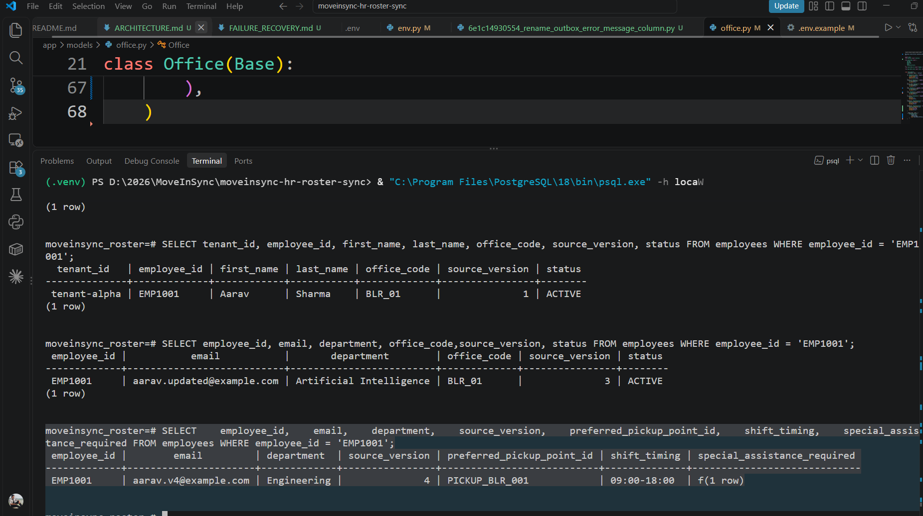

What we proved:
- HR can update HR-owned fields.
- Transport can update transport-owned fields.
- HR updates do not overwrite transport-owned fields.
- Both domains can safely update the same employee record.
This demonstrates field-level ownership protection in a multi-domain system.

